 | Year 12 Specialist  TEST 3  7 May 2018  TIME: 50 minutes working Classpads allowed!  39 Marks 7 Questions

Name:_______________________________

Teacher: ____________________________

Note: All part questions worth more than 2 marks require working to obtain full marks.

Q1 (2 & 2 = 4 marks)
Consider a line with parametric equations
- Determine a vector equation

- Determine a cartesian equation.

Q2 (3 & 2 = 5 marks)
Consider a plane containing the three points A, B & C .
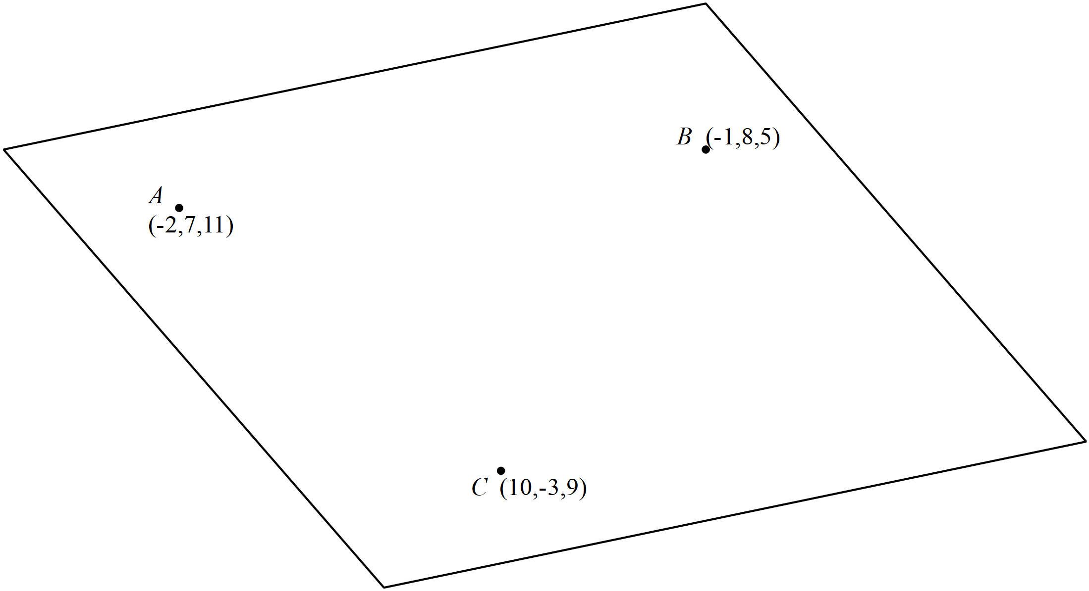
- Determine the vector equation of the plane.

Continued-
- Determine the cartesian equation of the plane(simplified) .

Q3 (4 marks)
Determine the distance of point P from the line

Q4 (4 marks)
Consider two particles A and B whose position at is recorded as below moving with constant velocities . Determine the distance of closest approach and the time that this occurs.

Q5 (2, 4 & 3 =9 marks)
OABCD is a pyramid. The height of the pyramid is the length of DE, where E is the point on the base OABC such that DE is perpendicular to the base.

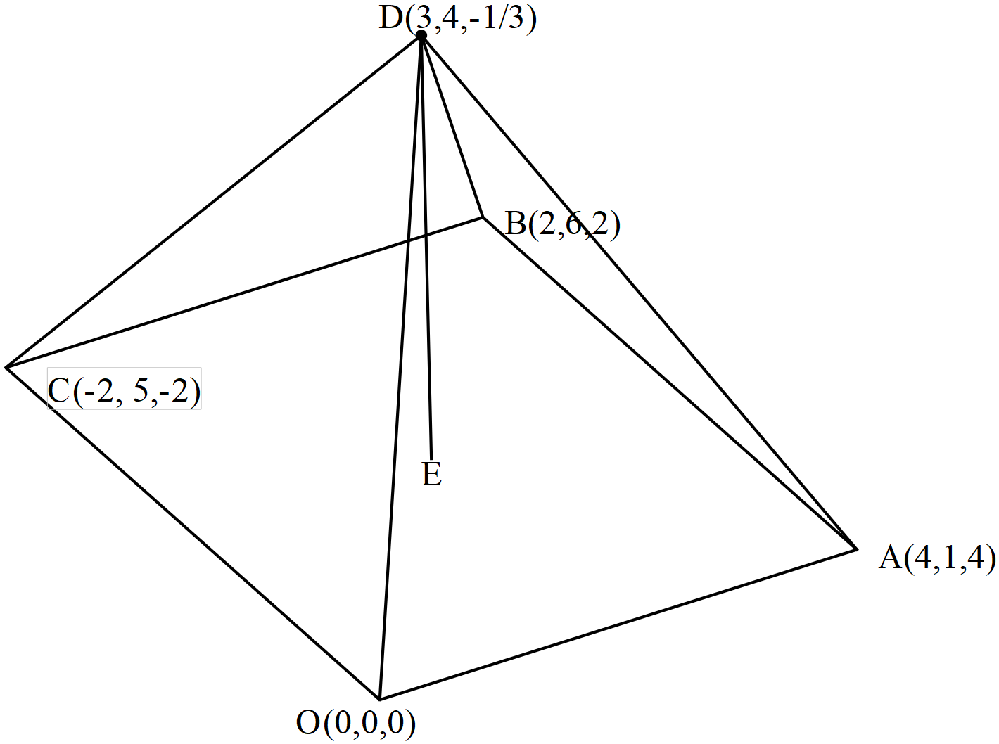

- Show that the base OABC is a rhombus.

The unit vector is perpendicular to both and .
- Show that and determine the exact values of .

- Hence determine the exact height of the pyramid.
Q6 (5 marks)
Consider a sphere of centre and radius of units , where is a constant.
The line is a tangent to the above sphere.

Determine the possible value(s) of

Q7 (2, 3 & 3 = 8 marks)
Consider the function where are constants.
The graph has a stationary point () at and passes through the point .
- Write down three linear equations satisfied by .

- Express in terms of without the use of a classpad.

- Determine the value of for which the graph has a stationary point where
(You may use a classpad here and show reasoning).

